*PRACTICAL:6*

*Write a program in Java to convert number into words & print it.*

import java.util.Scanner;

public class NumberToWords

{

public void pw(int n, String ch)

{

String one[] = { " ", " One", " Two", " Three", " Four", " Five", " Six", " Seven", " Eight", " Nine", " Ten",

" Eleven", " Twelve", " Thirteen", " Fourteen", "Fifteen", " Sixteen", " Seventeen", " Eighteen",

" Nineteen" };

String ten[] = { " ", " ", " Twenty", " Thirty", " Forty", " Fifty", " Sixty", "Seventy", " Eighty", " Ninety" };

if (n > 19)

{

System.out.print(ten[n / 10] + " " + one[n % 10]);

}

else

{

System.out.print(one[n]);

}

if (n > 0)

System.out.print(ch);

}

public static void main(String[] args)

{

int n = 0;

Scanner scanf = new Scanner(System.in);

System.out.println("Enter an integer number: ");

n = scanf.nextInt();

if (n <= 0)

{

System.out.println("Enter numbers greater than 0");

}

else

{

NumberToWords a = new NumberToWords();

a.pw((n / 1000000000), " Hundred");

a.pw((n / 10000000) % 100, " crore");

a.pw(((n / 100000) % 100), " lakh");

a.pw(((n / 1000) % 100), " thousand");

a.pw(((n / 100) % 10), " hundred");

a.pw((n % 100), " ");

}

}

}

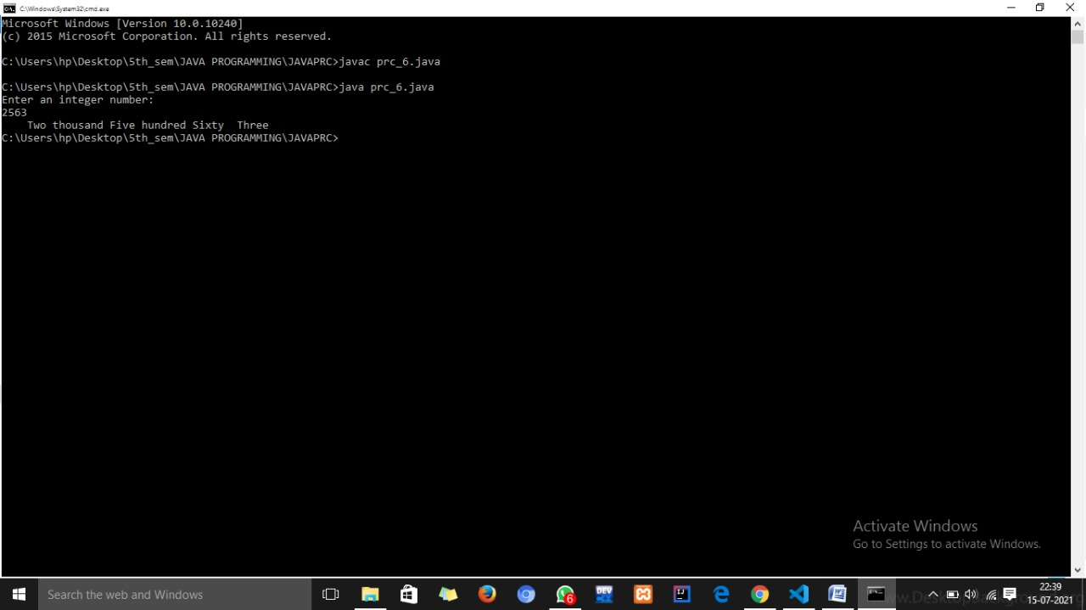

Name: aesha shah enrollment no.:196380307057